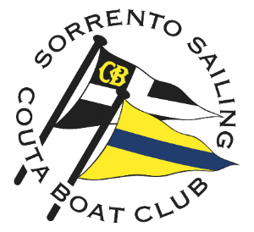

Marcus Burke
Wooden Launch Navigation Rally 2021
Times.
Nominated start time, waypoint times at South Ch. No. 7 and SSCBC West and finish time need to be submitted by the boat at time of entry. The Finish Window for all boats is 1230 - 1300.
Scoring.
Points are accumulated at South Channel No.7, SSCBC West, and at the finish. Each second off the nominated time equals 1 point deducted from the boat’s score.
Other tasks that are completed will accumulate points, the details of which are listed below the Course Instructions and the Course Diagram.

Course Instructions.
Course length 8.16 NM
MARK | NUMBER ON CHART | Leave Mark  To | DISTANCE NM | BEARING TRUE | LATITUDE | LONGITUDE
Box Start –  SSCBC X |  | Starboard |  |  | 38˚20.440'S | 144˚45.420’E
Sorrento Ch. No.4– this is a “no-wash” leg with boat-speed restricted to 3 knots | 1 | Starboard | 0.66 NM | 318 | 38˚19.948'S | 144˚44.860’E
Sorrento Ch. No.1– this is a “no-wash” leg with boat-speed restricted to 3 knots | 2 | Port | 0.54 NM | 331 | 38˚19.475'S | 144˚44.520’E
Virtual W.P. | 3 | Port | ?? | ?? | 38˚18.990'S | 144˚43.900’E
Port Lateral off Point Franklin | 4 | Starboard | ?? | ?? | 38˚18.970'S | 144˚43.090’E
South Ch. No.3 | 5 | Starboard | 0.82NM | 38 | 38˚18.320'S | 144˚43.730’E
South Ch. No. 7 | 6 | Starboard | 2.7 NM | 105 | 38˚19.005'S | 144˚47.050’E
SSCBC North | 7 | Starboard | 1.14 NM | 220 | 38˚19.880'S | 144˚46.120’E
SSCBC West | 8 | Starboard | 0.56 NM | 237 | 38˚20.189'S | 144˚45.524’E
Sorrento Ch. No. 8 | 9 | Port | 0.17 NM | 262 | 38˚20.214'S | 144˚45.309’E
Box Finish  SSCBC X |  | Port | 0.24 NM | 159 | 38˚20.440'S | 144˚45.420’E

For today’s event, you might assume a flood tide of 0.5 knots over the course. Its direction will vary and AUS158 may be helpful to choose the direction of the tidal stream. You may choose to ignore the tide and assume that your ETA at the critical waypoints will not be affected, but as a navigation exercise, the tide effect might be significant.

Course Diagram. 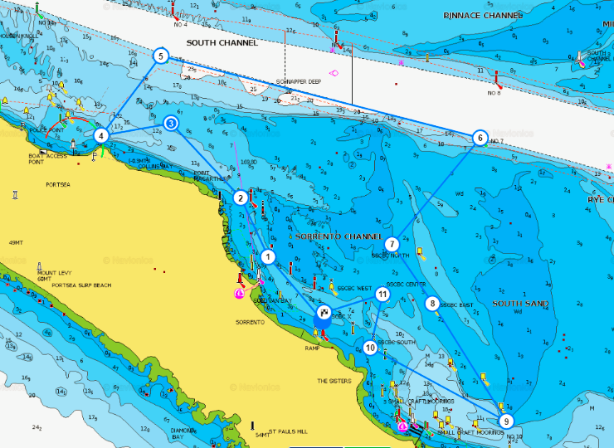
9
8
11
10
???

Scavenger Hunt.
Task 1. There is a “V” Flag displayed on SSCBC West? What does that signal mean to a vessel at a sailing regatta?
Task 2. What is your position when the western end of SSCBC jetty bears 256˚T at a distance 0.93 NM and the White quick flash light at the western end of Blairgowrie bears 191˚T at a distance 0.94 NM.
Task 3. What is the distance from the mark at approximately 38° 19.582’ S, 144° 44.714’ E, to the Sorrento Channel No.10?

Entry Form.
Boat Name: ……………………………………………. Registration Number: ……………………………………….

Skipper: ……………………………………………………….

Crew: ………………………………………………………….

Start Time: …………………. Cruising Speed: ………….knots Nominated Finish Time: …………………

Nominated time at South Ch. No. 7 : ……………………………………………………

Nominated time at SSCBC Centre : ……………………………………………………

Voyage plan:
Course length 8.16 NM
MARK | NUMBER ON CHART | Leave Mark  to | DISTANCE NM | BEARING ° TRUE | Estimated Time | Actual  Time
Box Start –  SSCBC X |  | Starboard
Sorrento Ch. No.4– this is a “no-wash” leg with boat-speed restricted to 3 knots | 1 | Starboard | 0.66 NM | 318
Sorrento Ch. No.1– this is a “no-wash” leg with boat-speed restricted to 3 knots | 2 | Port | 0.54 NM | 331
Virtual W.P. | 3 | Port
Port Lateral off Point Franklin | 4 | Starboard
South Ch. No.3 | 5 | Starboard | 0.82NM | 38
South Ch. No. 7 | 6 | Starboard | 2.7 NM | 105
SSCBC North | 7 | Starboard | 1.14 NM | 220
SSCBC West | 8 | Starboard | 0.56 NM | 237
Sorrento Ch. No. 8 | 9 | Port | 0.17 NM | 262
Box Finish  SSCBC X |  | Starboard | .24 NM | 159

Signed: ……………………………………………………………………….. Date: …………………………………

